
ENE211-0033/2024
WANGUI JOHN NJENGA
EEE B2

SMART POWER BILLING SYSTEM

INTRODUCTION

Smart Power Billing System is an inbuilt software that simplifies the management, calculation and reporting of electricity usage for the electricity provider. With the growing need for energy in the world, the shift from manual to automated digital meter readings has to become an absolute must. The system overcomes the challenges of today's electricity customer bases by breaking them down into unique groups, such as Residential, Commercial and Industrial, each with a different tariff design and time-based pricing model. The system is based on the Object Oriented Programming (OOP) paradigm that models real life objects. Using inheritance and polymorphism, the software can automatically use a different set of billing rules (tiered rates, demand charges) for different types of consumers without having to write any repetitive code. This keeps the system accurate and extremely scalable and hassle-free to maintain.

2. Purpose and Objectives

This system is mainly used to offer a dependable digital record to electricity distributors of their clients and economic status. The purpose of the key objectives is: Billing Automation: Reducing the time required to calculate complicated tiered tariffs, time-of-use (Day vs Night) surcharges and eliminating the possibility of human error. Data Persistence: Data handling methods for storing consumer data permanently and accessing it throughout multiple sessions. Sector-Specific Logic: Distinguishing high demand, heavy use commercial business from standard household uses, and heavy duty industrial demand. Business Intelligence: Providing administrative tools like total revenue reports and identification of top consumers to help with financial planning and grid load management.

3. Problem Statement

Dynamic pricing can be challenging for traditional billing systems. For example, a residential person may be encouraged to use energy at a lower cost under a tiered pricing system (where the price goes up as the energy consumed goes up), and an industrial user, for example, a factory, may be charged a fixed price with in addition a "Demand Charge" for the large infrastructure that is required for a factory. Human or simple spreadsheet management of such variations results in: Inconsistency: Applying “Day/Night” shifts inconsistently over thousands of records. Lack of Transparency: It is difficult for consumers to know how the final bill was compiled from units used. 3. Data Fragmentation: Not being able to remember what was happening in the past when systems have not been backed up to persistent storage. The Smart Power Billing System addresses these issues by consolidating all logic in a unified application in C++ that strictly follows rules and saves data on-the-fly.

4. System Scope

For this project, the functional requirement is for a medium sized utility office. It includes: Consumer Management: Creating, searching, and deleting consumer profiles. Tiered Rate Engine: Automatically pricing the rate of a unit according to the thresholds of consumption (ksh 0-100ksh, ksh100-300ksh, ksh>300ksh units) The distinction of time periods of energy use – base rates adjusted for energy use during peak hours (Day) and off-peak hours (Night). • I/O System: Use reading and writing to a flat-file database (data.txt) for a simulated permanent database environment. Statistical Analysis: Creating reports on the company's overall revenue and which clients are the best to work with, for loyalty or audit reasons.

5. Technical Stack Overview

The system has been designed to be highly performant and memory efficient, using C++17/20: Polymorphism: one "Consumer" pointer to call different billing math functions using virtual functions. To ensure modern memory safety and prevent memory leaks, smart Pointers (unique ptr). • STL Containers (vector): To store objects for consumers dynamically. • I/O Streams: To handle files and formatted console output.

System Architecture

Smart Power Billing System is a desktop C++ program for managing electricity billing of Residential, Commercial and Industrial customers. It's based on a four-layer Object Oriented design, defined and well-documented responsibilities between layers.

Architecture Layers

Layer | Name | Components | Role
1 | User Interface | Console Menu  main() | Accepts keyboard input; displays menus, results, and errors to the user
2 | Business Logic | Consumer, Residential, Commercial, Industrial | Applies billing rules, tiered rates, and OOP hierarchy per consumer type
3 | Analytics | Analytics class — static methods | Computes revenue totals, highest bills, and ID-based searches
4 | Data Persistence | save() / load() / data.txt | Serialises and deserialises consumer records to the file system

Architecture Diagram

LAYER 1 — USER INTERFACE
int main() · Console Menu · cin / cout
▼
Residential  Day 8 / Night 4 Ksh | Commercial  Day 12 / Night 9 Ksh | Industrial  Day 15 / Night 11 + 500 Ksh
▼
LAYER 3 — ANALYTICS
Analytics::revenue() | Analytics::highestBill() | Analytics::search()
▼
LAYER 4 — DATA PERSISTENCE
save() | load() | data.txt (flat-file storage)

Component Descriptions

Component | Description
Consumer (Abstract Base) | Holds shared fields (id, name, units, period) as protected. Declares pure virtual calculateBill() and getType() — cannot be instantiated directly.
Residential | Inherits Consumer. Applies day rate Ksh 8 / night Ksh 4 with tiered surcharges based on unit brackets.
Commercial | Inherits Consumer. Higher rates (day Ksh 12 / night Ksh 9) reflecting business usage.
Industrial | Inherits Consumer. Highest rates (day Ksh 15 / night Ksh 11) plus a fixed Ksh 500 demand charge.
Analytics (static) | Provides revenue(), highestBill(), and search() as static utility methods operating on the shared consumer vector.
save() / load() | Global functions that write/read consumer records to/from data.txt using space-separated field serialisation.
main() | Program entry point. Owns the consumer vector and runs the do-while menu loop dispatching to all other components.

2. System Block Diagram

The block diagram shows the five functional modules of the system and how data signals flow between them — from user input through object creation, billing, analytics, and finally persistence.

2.1 Functional Block Diagram
BLOCK 1: INPUT MODULE
Reads: ID · Name · Units · Type (1/2/3) · Period (0/1) via cin
▼ validated structured input
BLOCK 2: OBJECT FACTORY
make_unique<Residential | Commercial | Industrial>(…) → stored in vector<unique_ptr<Consumer>>
▼ Consumer* (polymorphic pointer)
BLOCK 3: BILLING ENGINE
calculateBill() + tieredRate() → Ksh amount (float)
▼ bill amounts (float)
BLOCK 4: ANALYTICS MODULE
revenue() · highestBill() · search() → console output
▼ serialised text records
BLOCK 5: FILE PERSISTENCE
save() → data.txt | data.txt → load() (on startup)

2.2 Block Descriptions
Block | Function | Why Required
Block 1: Input Module | Reads consumer data via cin. Validates units >= 0. Maps integer type and period choices to Enum values and subclass constructors. | Structured, validated input prevents invalid records from entering the system and corrupting billing calculations.
Block 2: Object Factory | Uses make unique<>() to create the correct Consumer subclass and stores it as a polymorphic pointer in the vector. | Decouples object creation from usage. All downstream code interacts only with Consumer* — no type-checking needed.
Block 3: Billing Engine | Each subclass overrides calculateBill() with its rate formula. tieredRate() applies +2 Ksh (101–300 units) and +5 Ksh (>300 units) surcharges. | Rate structures differ by consumer category. Per-class methods isolate each tariff so changes to one type cannot affect another.
Block 4: Analytics | Static methods iterate the consumer vector to sum all bills, find the maximum, or search by ID. Results printed to console. | Analytics is a distinct responsibility. Static design means no Analytics object is needed — they are utility operations on shared state.
Block 5: File Persistence | save() writes each consumer's fields as a text line. load() reads those lines and reconstructs objects via the factory pattern on startup. | Without this block all data is lost on program exit. Flat-file design requires no database engine, keeping the system self-contained.

3. Data

This section describes the types of data the system handles at each stage — what is received, how it is transformed, and what is output or stored.

3.1 Data Types
Data Item | C++ Type | Range / Example | Description
Consumer ID | int | e.g. 1001 | Unique numeric identifier for the billing account
Consumer Name | string | e.g. "Kamau" | Account holder name (single whitespace-free token)
Units Consumed | float | >= 0, e.g. 250.5 | Electricity used in kilowatt-hours (kWh)
Consumer Type | subclass | Residential / Commercial / Industrial | Determines which billing formula is applied
Time Period | enum TimePeriod | DAY=0 / NIGHT=1 | Selects day or night tariff rate
Calculated Bill | float | Ksh 0 – ∞ | Result of calculateBill(): units × rate ± charges
Total Revenue | float | Sum of all bills | Aggregate produced by Analytics::revenue()
File Record | text line | "Residential 1001 Kamau 250.5 0" | Space-separated serialised record in data.txt

3.2 Data Flow per Module
Module | Data Received | Data Processed | Data Output / Stored
Input Module | Raw keyboard input via cin | Validation (units >= 0); mapping int to enum and subclass | Typed constructor parameters passed to make_unique<>()
Object Factory | id, name, units, TimePeriod | Selects correct subclass constructor from type integer | unique_ptr<Consumer> appended to vector
Billing Engine | units, period (object fields) | Applies base rate, tieredRate() surcharge, optional demand charge | calculateBill() returns float bill amount
Analytics Module | Reference to consumer vector | Iterates; calls calculateBill() per element; compares or sums | Console output: revenue total, highest-bill consumer, search result
save() | Consumer vector reference | Calls getType/Id/Name/Units/Period getters per object | Text lines written sequentially to data.txt
load() | Raw text lines from data.txt | Parses fields; maps type string to make_unique<> call | Populated vector<unique_ptr<Consumer>> returned to main()

4. OOP Fundamentals and Implementation

OOP structure is in terms of objects, which contain data and behaviour. This project also has the four pillars: Encapsulation, Inheritance, Polymorphism and Abstraction.

4.1 Encapsulation
The main idea of encapsulation is that it encapsulates data and the methods that manipulate the data are combined in one unit and it does not allow direct access to the internal state from outside interference.
In this program, the following methods are used for encapsulation: Protected/private data members: The base class Consumer has its attributes (id, name, units, period) declared as protected. This will keep the external access blocked, but will give derived classes the ability to use them directly. Only getId(), getName(), getUnits(), and getPeriod() public getter methods allow access to the attributes outside of the class hierarchy.
No public setters, changes to it are only via constructor, this maintains integrity. Encapsulated billing logic: Each derived class has its own tariff logic within the overridden calculateBill() method. The outside world never sees how the bill is computed – it only calls the virtual function.
class Consumer {
protected:
int id; // Hidden — cannot be accessed directly
string name;
float units;
public:
int getId() { return id; } // Controlled read access
string getName() { return name; }
// No setters — data is immutable after construction
};

4.2 Inheritance
The inheritance enables the new classes to reuse, extend and modify the behavior of the existing classes. The priority for bills is based solely on inheritance: Common properties such as id, name, units and period are defined in base class Consumer, along with general display logic.
The derived class Residential, Commercial and Industrial are derived from Consumer with public hidden class Residential : public Consumer, class Commercial : public Consumer, class Industrial : public Consumer. They inherit all the base attributes and display() method. Overriding of the pure virtual functions calculateBill() and getType() provides each derived class with its own specialisation.

class Residential : public Consumer {
public:
Residential(int i, string n, float u, TimePeriod p)
: Consumer(i, n, u, p) {} // Reuses parent constructor

float calculateBill() override { ... }
string getType() override { return "Residential"; }
};

4.3 Polymorphism
A polymorphism (many forms) can be used to have one interface that can have many different underlying implementations. The program uses runtime polymorphism via virtual functions and base class pointers. Virtual functions: The calculateBill() and getType() functions are declared virtual in the base class and redefined in each derived class.
If these functions are called with Consumer* or Consumer&, the correct derived function is called dynamically at runtime, based on the type of the actual object. Homogeneous container of heterogeneous objects: A std::vector<std::unique_ptr<Consumer>> holds objects that are unique_ptr<Residential>s, unique_ptr<Commercial>s, and unique_ptr<Industrial>s. Loops over this vector call c->calculateBill() and c->display(), but each call sends to the respective subclass implementation.
In the Analytics class, the calls to Analytics::revenue(), Analytics::highestBill(), and Analytics::search() are polymorphic: they do not perform any type checking logic, and call the same method, calculateBill() (display()) in each case.
The key principle of polymorphism is that you don't write code for a specific type. When we use file loading we will create polymorphic objects: When the load() function reads a type string, it creates a Residential, Commercial or Industrial object and stores them as a unique_ptr<Consumer>. From there on it's treated as a generic object.

// The vector holds Consumer* pointers (base type)
for (auto& c : consumers) {
// At runtime, C++ dispatches to the correct subclass:
// Residential::calculateBill() OR
// Commercial::calculateBill() OR
// Industrial::calculateBill()
cout << c->calculateBill();
}

4.4 Abstraction
Abstractness concentrates on the key features and obscures the complicated implementation parts. The program has several layers of abstraction: • Abstract base class Consumer: It defines two pure virtual functions – calculateBill() and getType(). This means that the class Consumer is not a class which you can create an instance of directly but rather an abstract class. It gives all types of consumers a common interface without dictating the bill calculation mechanism. All the application (main menu, Analytics functions, file operations) uses vector<unique_ptr<Consumer>> as common interface. This level of code doesn't know at all what each consumer is, it just works with the abstract interface. This helps to separate the high level logic from the low level billing algorithms. As a template method: The display() method of the base class calls virtual getType() to display the category of the consumer. The derived classes need only to override getType(), and will have the same display structure as the base class. This is a definite distinction between “what to do” and “how exactly it is done”.
class Consumer {
public:
virtual float calculateBill() = 0; // Pure virtual — MUST override
virtual string getType() = 0; // Pure virtual — MUST override
virtual ~Consumer() {} // Virtual destructor for safe cleanup
};

// This is ILLEGAL — compiler rejects it:
// Consumer c(1, "Ali", 100, DAY); // error: abstract class

OOP Pillar | Where Used | Benefit in This System
Encapsulation | protected fields in Consumer; public getter methods | Prevents external code from corrupting consumer data fields
Inheritance | Residential, Commercial, Industrial extend Consumer | Eliminates duplication of id, name, units, display() across three classes
Polymorphism | virtual calculateBill() dispatched at runtime via Consumer* | Analytics and UI loops handle any consumer type without branching
Abstraction | Consumer is abstract (pure virtual = 0 methods) | Enforces that every new consumer type must implement billing logic

REMARKS
The Smart Power System is an example that is textbook perfect in terms of OOP design: Encapsulation: Encapsulating the internal state of each consumer and hiding tariff logic in specialised classes.
The high level program flow is simplified because of abstraction which provides a pure virtual interface for billing that hides complexity. The inheritance allows code to be reused by sharing common attributes and the display() method for all types of consumers.
A collection of different consumer types can be treated uniformly by the system, and it's easy to extend and maintain. This code will have low coupling, high cohesion, and a great scalability: Adding a new consumer type will only need a new subclass and a minor modification to the load() factory, and the rest of the application will remain untouched.

5. System Flowcharts

5.1 Main Program Flowchart
The flowchart below shows the full execution path of the program from startup through the menu loop to exit. The do-while loop repeats until the user selects option 9.

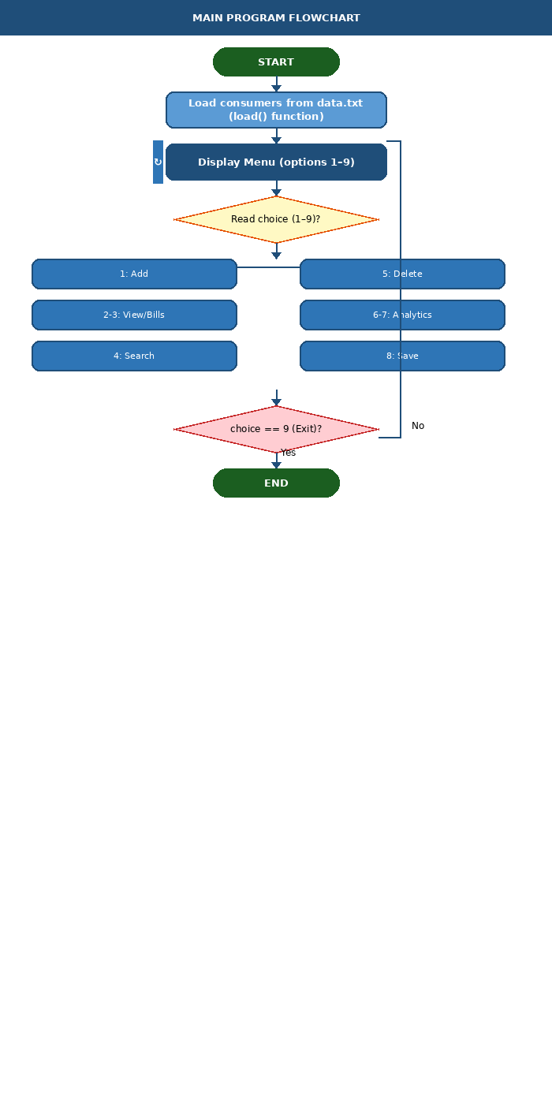

5.2 Billing Engine Flowchart
This flowchart details how calculateBill() works across all three consumer types, including the tieredRate() surcharge logic and the Industrial demand charge.

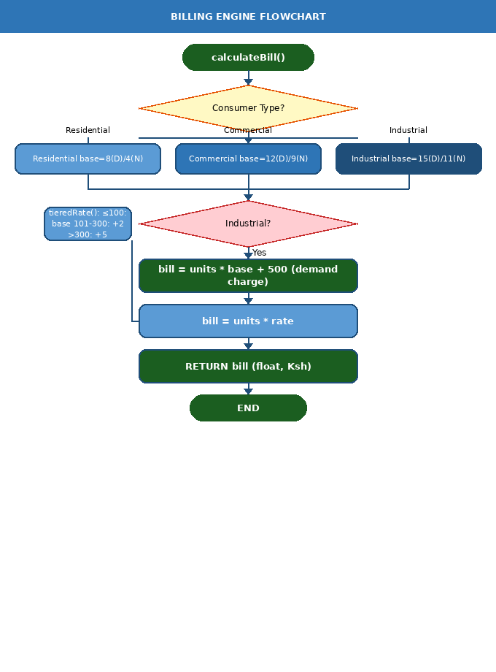

5.3 File Save & Load Flowchart
This dual-column flowchart shows the save() function (left) and load() function (right) side by side, illustrating the symmetric read/write operations on data.txt.

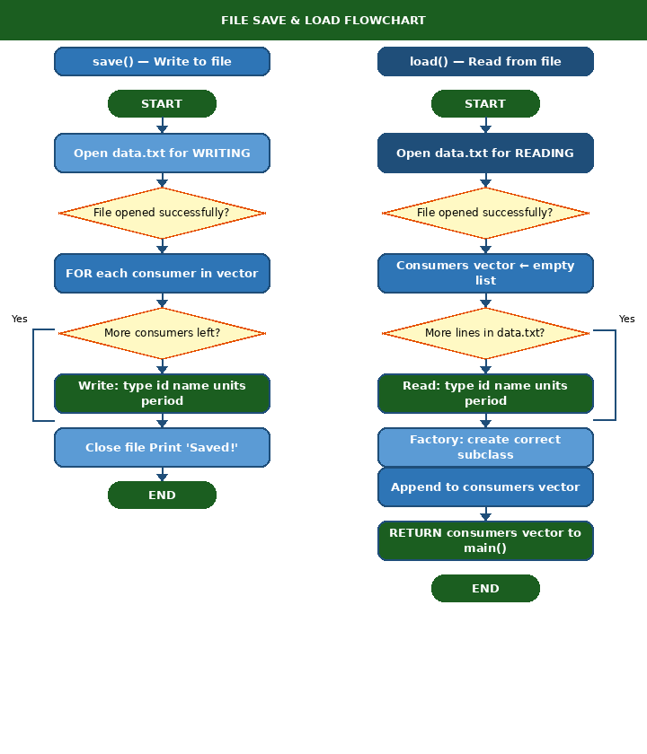

6. Code Implementation Analysis

6.1 Main Program Loop — Pseudocode

BEGIN
consumers ← load() // Restore saved records on startup

REPEAT
Display menu (options 1–9)
Read choice

IF choice == 1 THEN // Add Consumer
Read id, name, units, type, period
IF units < 0 THEN print error; CONTINUE
Instantiate correct subclass via make_unique<>()
Push to consumers vector

ELSE IF choice == 2 THEN // View all consumers
FOR each c IN consumers: c.display()

ELSE IF choice == 3 THEN // Show bills
FOR each c IN consumers: c.display() + c.calculateBill()

ELSE IF choice == 4 THEN // Search by ID
Read id; Analytics::search(consumers, id)

ELSE IF choice == 5 THEN // Delete by ID
Read id; remove_if(consumers, id); consumers.erase()

ELSE IF choice == 6 THEN // Revenue report
Analytics::revenue(consumers)

ELSE IF choice == 7 THEN // Highest bill
Analytics::highestBill(consumers)

ELSE IF choice == 8 THEN // Save data
save(consumers)

UNTIL choice == 9
END

6.2 Billing Engine — Pseudocode

FUNCTION tieredRate(units, dayRate, nightRate) → float
IF units <= 100 THEN rate ← dayRate
ELIF units <= 300 THEN rate ← dayRate + 2
ELSE rate ← dayRate + 5
RETURN rate

FUNCTION Residential::calculateBill() → float
base ← (period == DAY) ? 8 : 4
rate ← tieredRate(units, base, base)
RETURN units * rate

FUNCTION Commercial::calculateBill() → float
base ← (period == DAY) ? 12 : 9
rate ← tieredRate(units, base, base)
RETURN units * rate

FUNCTION Industrial::calculateBill() → float
base ← (period == DAY) ? 15 : 11
RETURN (units * base) + 500 // Fixed demand charge

6.3 Analytics — Pseudocode

FUNCTION revenue(consumers)
total ← 0
FOR each c IN consumers: total ← total + c.calculateBill()
PRINT "Total Revenue: Ksh " + total

FUNCTION highestBill(consumers)
IF consumers is empty: RETURN
maxC ← consumers[0]
maxBill ← consumers[0].calculateBill()
FOR each c IN consumers
IF c.calculateBill() > maxBill
maxBill ← c.calculateBill()
maxC ← c
PRINT maxC.display(); PRINT maxBill

FUNCTION search(consumers, id)
FOR each c IN consumers
IF c.getId() == id
PRINT c.display(); PRINT c.calculateBill(); RETURN
PRINT "Consumer not found"

7. File Saving and Loading
The system persists consumer records using a plain-text file (data.txt). Each line stores one consumer's fields, space-separated, in the format shown below.

7.1 File Format
Format: <Type> <ID> <Name> <Units> <Period>

Example data.txt:
Residential 1001 Kamau 150 0
Commercial 1002 NairobiMall 450 1
Industrial 1003 CementFactory 1200 0

7.2 Save Function — Pseudocode
FUNCTION save(consumers)
OPEN 'data.txt' for WRITING (overwrites existing)
FOR each consumer c IN consumers
WRITE c.getType() + ' ' + c.getId() + ' ' + c.getName()
+ ' ' + c.getUnits() + ' ' + c.getPeriod() + newline
CLOSE file
PRINT 'Saved successfully!'

7.3 Load Function — Pseudocode
FUNCTION load() → vector<Consumer*>
consumers ← empty vector
OPEN 'data.txt' for READING
WHILE file has unread data
READ type, id, name, units, period
p ← cast period integer to TimePeriod enum
IF type == 'Residential' THEN append Residential(id,name,units,p)
ELIF type == 'Commercial' THEN append Commercial(id,name,units,p)
ELIF type == 'Industrial' THEN append Industrial(id,name,units,p)
RETURN consumers

7.4 File Handling Limitations

Limitation | Impact | Recommended Fix
Names with spaces break parsing | 'John Kamau' splits into two tokens, corrupting the record | Use CSV or JSON format with quoted string fields
No error handling on file open | Silent failure if data.txt is missing or permission is denied | Check file.is_open() and show a meaningful error message
No data integrity check | Corrupted or manually edited file loads garbage data without warning | Add a checksum or version header line
Complete overwrite on every save | No backup or history — power cut mid-write destroys all data | Write to a temp file, then rename atomically, and keep a backup
No concurrent access protection | Two running instances corrupt each other's data.txt | Use file locking (flock) or migrate to SQLite

8. System Improvements and Applications

8.1 Code-Level Improvements

Issue | Current Behaviour | Recommended Fix
tieredRate nightRate unused | nightRate is accepted but never used — all periods use dayRate | Remove the parameter or apply nightRate for NIGHT period consumers
calculateBill() called twice in highestBill() | Each consumer's bill is computed twice per iteration — wasteful | Cache result in a local variable before comparison
No duplicate ID check | Adding a duplicate ID causes ambiguous search and delete | Scan the vector for existing ID before inserting
No input sanitisation | A non-integer at the menu causes cin to fail and loops forever | Check cin.fail() after every read; call cin.clear() + cin.ignore()
Hard-coded billing rates | Rates like 8, 12, 15 are embedded — changing requires recompile | Move rates to a config file or a constants header

8.2 Architectural Enhancements
- Replace data.txt with an SQLite database for concurrent access, queries, and referential integrity.
- Add a GUI front-end using Qt so non-technical meter readers can operate the system without a console.
- Introduce a BillingPeriod class tracking month and year to enable historical bill comparison and trends.
- Add a Payment class to record payments, compute outstanding balances, and flag overdue accounts.
- Implement PDF invoice generation per consumer using a PDF library such as libharu or pdfium.
- Add role-based access control — administrators edit rates; operators can only add or view consumers.

8.3 Real-World Applications

Domain | How This System Could Be Deployed
Rural electrification | Managing prepaid meter data for off-grid solar mini-grids serving residential and small commercial consumers in underserved areas
Estate management | Billing tenants across multiple properties with different tariff structures applied per consumer category
Industrial parks | Tracking demand charges and peak vs off-peak consumption for manufacturing clients on time-of-use tariffs
University campuses | Apportioning electricity costs to faculties or departments based on sub-meter readings
Small municipal utilities | A basic billing system for councils without budget for enterprise SCADA or ERP software

9. Critical Flaws of the System
While the system demonstrates solid OOP principles, several flaws limit its reliability and suitability for production use. These are documented below with severity ratings.

# | Flaw | Severity | Explanation
1 | Input loop breaks on non-integer | HIGH | Typing a letter at the menu prompt puts cin into a fail state and causes an infinite menu-printing loop with no recovery.
2 | Spaces in names break file parsing | HIGH | The load() function uses >> which splits on whitespace. 'Mary Wanjiru' is parsed as 'Mary' for name and 'Wanjiru' for units, corrupting the record silently.
3 | tieredRate nightRate parameter unused | MEDIUM | The night-rate parameter is accepted but ignored — the formula only uses dayRate. Night-period consumers never benefit from lower off-peak pricing in the tiered bracket, causing billing errors.
4 | No duplicate ID prevention | MEDIUM | Multiple consumers can share the same ID. Search returns only the first match; delete removes one arbitrarily, leading to incorrect billing.
5 | calculateBill() called redundantly | LOW | highestBill() calls calculateBill() on every consumer twice per iteration — once for comparison, once for output. This doubles computation for large datasets.
6 | No payment or balance tracking | HIGH | Bills are generated but there is no record of whether they have been paid, partially settled, or are overdue. No accounts-receivable report is possible.
7 | No backup before save | MEDIUM | save() immediately overwrites data.txt. A power cut mid-write destroys all data with no recovery option.
8 | Single-user, single-machine only | HIGH | The flat file and lack of networking mean multiple operators cannot use the system simultaneously, and no remote access is possible.

Conclusion
The implementation of the Smart Power Billing System is a major stride in the modernization of power utilities using sound principles of software engineering. The system eliminates the need for manual calculations and disjointed record-keeping, creating a single, automated platform with increased transparency, accuracy, and efficiency in billing operations. Summary of Achievements
The project successfully implemented a multifaceted billing engine that addresses the diverse needs of a modern power grid:
- Logical Scalability: Through the use of Object-Oriented Programming (OOP), the system can seamlessly integrate new consumer types or tariff structures (such as Solar or Green Energy tiers) without restructuring the core codebase.
- Algorithmic Precision: The implementation of Tiered Rate Logic ensures that energy conservation is incentivized for residential users, while the Industrial Demand Charge model ensures that the heavy infrastructure costs of manufacturing are recovered fairly.
- Data Integrity: Using File I/O operations and the latest memory management techniques in C++ (Smart Pointers), the system ensures that data is not lost and that there are no memory leaks, ensuring a safe environment for data storage over time.

Impact on Stakeholders

The system has clear benefits for the utility provider and for the end-user: For the Utility Provider: It provides high-level business intelligence, with revenue reports and consumer analytics to facilitate financial forecasting and resource planning. For the consumer, it makes sure that bills are generated with a uniform and error-free calculation logic, separating day and night usage and builds trust between the service provider and the consumer.

Future Recommendations
- The current system is a strong standalone solution that can be developed into more sophisticated technological integrations. The following enhancements are suggested for future use of the Smart Power Billing System:
- Database Migration: Swapping out the flat-file storage (.txt) to a Relational Database Management System (RDBMS) such as SQLite or PostgreSQL for millions of records and faster query speeds.
- Cloud Integration: Migrating the entire solution to a web dashboard with a C++ web framework and enabling administrators to manage revenues from anywhere.
- Smart Meter IoT Integration: An integration using an API to connect the system directly with the IoT-enabled smart meters, instead of manually entering the units.
- Security Implementation: Incorporating user authentication and data encryption to safeguard financial details and sensitive customer data.

Final Remarks
To sum up, the Smart Power Billing System is not a mere calculator, rather it's a total administration instrument. It showcases the power of strategic use of C++ to tackle real-life logistical problems and offers a template for building utility software for tomorrow's needs that's dependable as the power grid it serves.

THE OUTPUT OF MY SYSTEM

ADDING A CUSTOMER

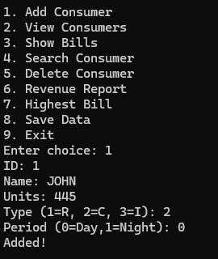

VIEWING CUSTOMERS

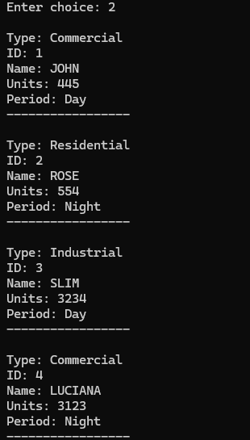

SHOW ALL BILLS

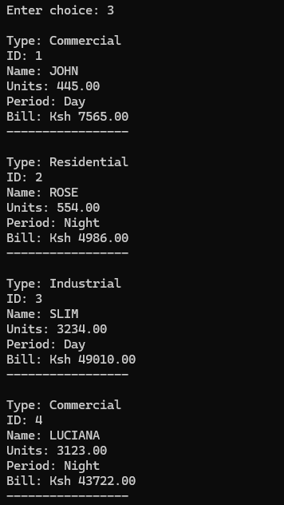

SEARCH CUSTOMER

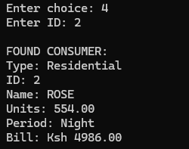

DELETE A CUSTOMER

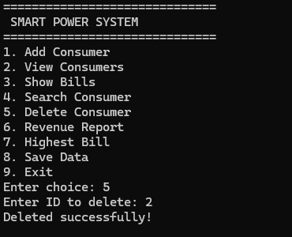

REVENUE REPORT

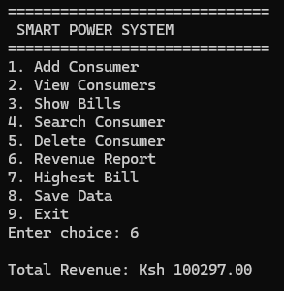

HIGHEST BILL

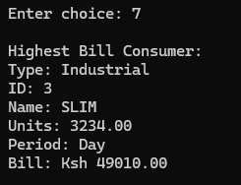

SAVE DATA

